Dear customer, thank you for your trust in Shandong Yuying. In order to facilitate communication between the two parties, please patiently fill in the following content with your technical staff.（**尊敬的客户，感谢您对山东宇影的信任，为了便于双方沟通以下内容请贵司技术人员耐心填写**）

客户名称/Client’s Name： 产品型号/Product model

日期/Date： 客户确认/ Client confirmation：

1. **安装,使用要求/Installation and usage requirements**
2. 壁挂Wall mounting：如图一(Figure 1) 吸顶Ceiling：如图二 (Figure 2)

注：壁挂或吸顶设计不同，一般不通用

（Note: Wall-mounted or ceiling-mounted designs are different and generally not universal.）

Figure1

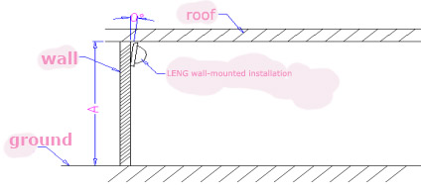

Figure 2

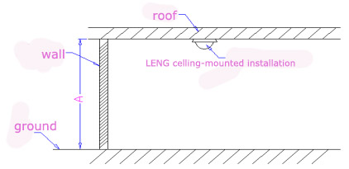

1. 安装高度\_\_\_\_\_\_米 .（如图1或图2的Ａ处（放置高度）），桌面放置及门铃类都属于壁挂，不同的安装高度侦测结果是不同的， 建议您填写确切的数值，高度范围不要超过0.3米

The installation height is\_\_\_\_\_meters. (A in Figure 1 or Figure 2 (placement height)). Desktop placement and doorbells are both wall-mounted. The detection results are different for different installation heights. It is recommended that you fill in the exact value and height range. No more than 0.3 meters

*IMG_256*

3.壁挂时产品倾斜 度 注：如图1之θ，倾斜角度会影响侦测的效果，如距离及角度

Product tilt angle is\_\_\_\_\_degree\_when wall-mounted Note: As shown in θ in Figure 1, the tilt angle will affect the detection effect, such as distance and angle.

4.背景温度 ℃（常规为25℃±2℃）注：背景温度直接影响侦测效果，温度越高距离越短

Ambient temperature :\_\_\_\_\_\_\_℃ (normally 25℃±2℃) Note: The ambient temperature directly affects the detection effect. The higher the temperature, the shorter the distance.

1. 产品应用场景/Product application scenario:
2. **结构参数Structural parameter**

**1.**sensor数目/sensor number:

2.Sensor相对于透镜及产品位置　请提供3D图纸或带线路样机。

Sensor倾斜角度为 　度 或 由宇影设计　（如图3）

The position of the sensor relative to the lens and product. Please provide 3D drawings or prototypes with circuits.

Sensor tilt angle is\_\_\_ degrees. Or designed by YUYING. (Figure 3) 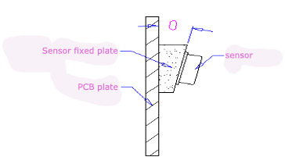

3.焦距为＿＿　mm或按实际客供外壳测量

焦距为探头正前方向探头感应元中心到透镜顶部的距离

The focal length is \_\_＿mm or measured according to the actual customer-supplied housing.(The focal length is the distance from the center of the sensor element of the probe to the top of the lens in the direction directly in front of the probe.)

4.镜片安装后成平面(如图4) 或 圆柱面(如图5)或球面（如图6）或异形（如图7）

After installation, the lens becomes a flat surface (Figure 4) or a cylindrical surface (Figure 5) or a spherical surface (Figure 6) or a special shape (Figure 7)

Figure 4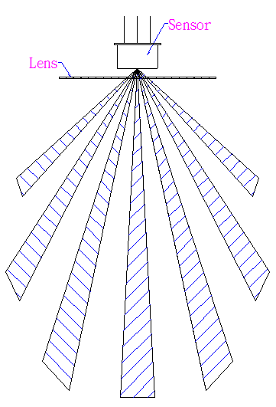 Figure 5 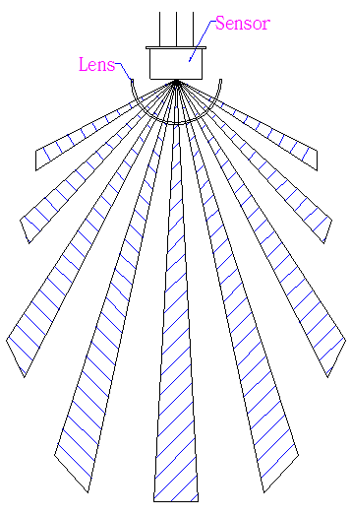

*IMG_256*

Figure 6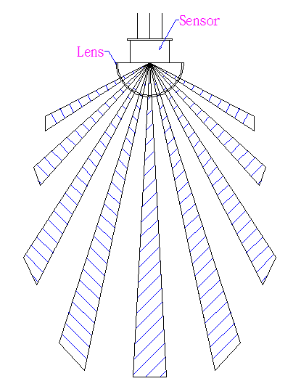 Figure 7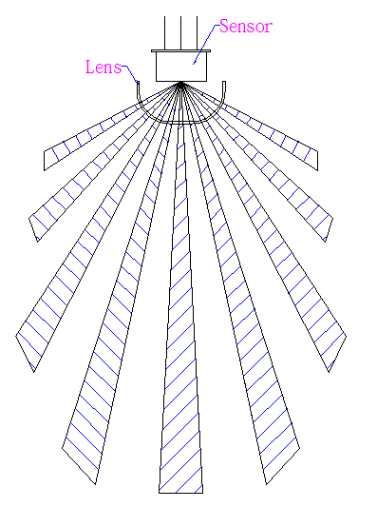

5.透镜光学区域尺寸长　　　　mm宽　　　mm　或直径　　　 mm

建议客户提供外壳,支架及PCB板3D图纸**(避免透镜设计发生干涉)**

Lens optical area size ,length:\_\_\_\_\_\_ mm ,width:\_\_\_\_\_\_ mm or diameter:\_\_\_\_ mm

It is recommended that customers provide housing,bracket and 3D drawings of the PCB board (to avoid interference in the lens design).

1. **电路设计 Circuit design**

1.Sensor(传感器)厂牌　 型号　 注：不同Sensor，其参数会影响侦测距离及角度

PIR sensor brand:\_\_\_\_\_\_ model number:\_\_\_\_\_\_

note:Different Sensor parameters will affect the detection distance and angle.

2.电路放大倍率是多少? 倍

The magnification of the circuit?\_\_\_\_\_\_times.(In the later stage, the magnification should be evaluated and adjusted according to the actual use effect.)

3..其他要求others：

1. **探测要求Detection requirement**

Figure 8 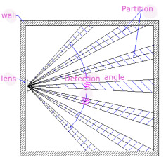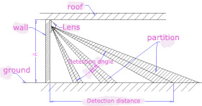

Figure 9

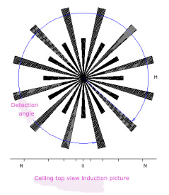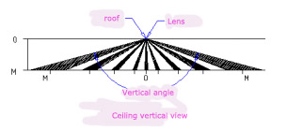

Figure 10 Figure 11

1. 壁挂探测水平角度及距离： 　 　　 度 ＿＿＿ 米(如图8)

Wall mounting Horizontal detection Angle and detection distance:\_\_\_\_\_\_ degree,\_\_\_\_\_meters.

(Figure 8)

1. 壁挂探测垂直角度及距离： ＿＿ 度 米 (如图9)

Wall mounting Vertical detection Angle and detection distance:\_\_\_\_\_\_ degree,\_\_\_\_\_meters. (Figure 9)

1. 吸顶探测俯视角度及距离： ＿度 ＿＿米 （如图10）

Ceiling detection top view angle and distance:\_\_\_\_\_\_ degree,\_\_\_\_\_meters. (Figure 10)

1. 吸顶探测垂直角度及距离： 　 度 米 （如图11）

Ceiling detection vertical angle and distance:\_\_\_\_\_\_ degree,\_\_\_\_\_meters. (Figure 11)

1. 按行业标准进行测试Test according to industry standards
2. 客户附加感应探测需求（根据实际应用场景填写：如微动作，抗白光及防宠物等）

Customer’s additional induction detection requirements ( based on actual application scenarios: such as micro-movement, anti-white light, anti-pet, etc.)

\_\_\_\_\_\_\_\_\_\_\_\_\_\_\_\_\_\_\_\_\_\_\_\_\_\_\_\_\_\_\_\_\_\_\_\_\_\_\_\_\_\_\_\_\_\_\_\_\_\_\_\_\_\_\_\_\_\_\_ \_\_\_\_\_\_\_\_\_\_\_\_\_\_\_\_\_ \_\_\_\_\_\_\_\_\_\_\_\_\_\_\_\_\_\_\_\_\_\_\_\_\_\_\_\_\_\_\_\_\_\_\_\_\_\_\_\_\_\_\_\_\_\_\_\_\_\_\_\_\_\_\_\_\_\_\_\_\_\_\_\_\_\_\_\_\_\_\_\_\_\_\_\_\_\_\_\_\_\_\_\_\_\_\_\_\_\_\_\_\_\_\_\_\_\_\_\_\_\_\_\_\_\_\_\_\_\_\_\_\_\_\_\_\_\_ \_\_\_\_\_\_\_\_\_\_\_\_\_\_\_\_\_\_\_\_\_\_\_\_\_

**(光学部分分区由宇影设计，按客户意图设计透镜，达到客户需求的角度、距离参数，建议客户提供样机或PCB板)**

（The optical part partition is designed by Yuying. The lens is designed according to the customer's intention to achieve the angle and distance parameters required by the customer. It is recommended that the customer provide a prototype or PCB board.)

1. **其他要求**Others
2. 抗UV设计 　　 是　 否 注：需要请注明规范

Anti-UV design : YES □ NO □ ( note:Please specify specifications if necessary)

2. 产品颜色 : 原色 白色 黑色 按色板 其他

Product colour : primary colour □ Black □ White □

Follow colour palette □ Others □